C/C++ STRING REVERSAL LAB REPORT

1) Enter your name, student ID, platform (Mac or PC) and date
Name and Student ID: Brian Quintero 0842280
Class: CIS054 C/C++ Programming
Platform (Mac or PC): Pc
Date: 3/29/14

DESCRIPTION:
The project is described in the textbook, Chapter 9 PROGRAMMING PROJECTS #4.
Write a function that uses two pointers, front and rear. Reverse the string by swapping characters pointed to by front and rear. Increment the front pointer and decrement the rear pointer until the entire string has been reversed. Your program will need to determine when the string has been fully reversed and stop swapping characters. IMPORTANT: Your program must use pointer notation to reverse the string, not array notation.
Do not submit a program that uses an already available routine that reverses characters in a string.

LAB REPORT:
2) Determine the Inputs, Processing and Outputs before creating the program
INPUTS | PROCESSING | OUTPUTS
for (int N = 0; N < stringL / 2; N++)
{

char blank = *pFirst;
*pFirst = *pLast;
*pLast = blank;

pFirst++; //increment pointer
pLast--;//decrement pointer

}
return Initial;

3) Fill in the EXPECTED & ACTUAL RESULTS
TEST DATA VALUES  Provide examples of a string with an even number of characters and a string with an odd number of characters. | EXPECTED RESULT  Computed values before the program is run | ACTUAL RESULT  Fill in the output displayed  by the program
RaceCar  To the worlds End  San Jose City Community College | raCecar  dnE sdlrow eht oT  egelloC ytinummoC ytiC esoJ naS | raCecar  dnE sdlrow eht oT  egelloC ytinummoC ytiC esoJ naS

DISCUSSION:
4) Complete the DISCUSSION section. It does not need to be long, but it needs to be complete.
4a) What did you do to develop the program? ("Followed the Directions" is not a complete description)
I figured out how to use pointers to reverse letters from each side. Having to use the pointer from one side to transfer them over to another and having to keep going up the stream and down the stream so they would reverse symmetrically .

4b) What problems did you have and how did you overcome the problems?
The problems I had was figuring out the 3 way substitution, as the tutor asked me how to do it I was blanking but within a couple of minutes I devised a formula on how to do it.

PROGRAM OUTPUT:
5) Show screen shots for at least TWO strings that have been reversed. One string must have an EVEN number of characters and the other string must have an ODD number of characters.
Refer to previous lab assignments for instructions on how to capture a screen or portions of a screen for either the PC or a Mac
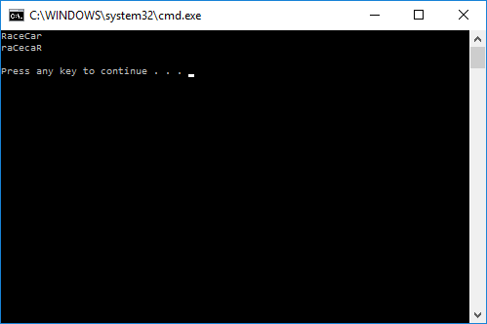
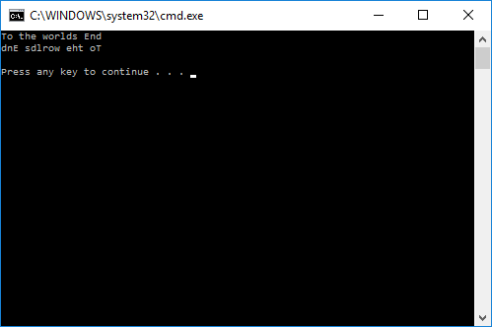
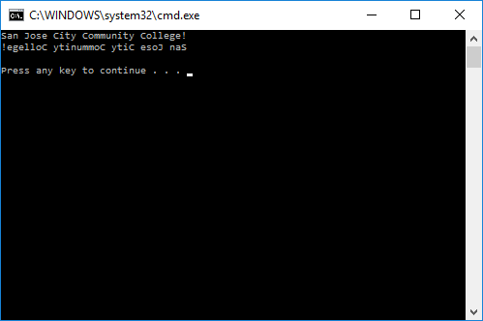

PROGRAM LISTING:
6) Copy and paste the code that YOU typed to make the program work. Your program should include a comment block at the top that shows the name of the program, date, version and your name.

// ConsoleApplication25.cpp : Defines the entry point for the console application.
//Brian Quintero 0842280
//Cis 054 C++ Programming
//Pc
//3/27/14

#include "stdafx.h"
#include <iomanip>
#include <iostream>

using namespace std;

char* ReverseT(char* Initial)
{

int stringL = strlen(Initial);
char *pFirst = &Initial[0]; //start of array
char *pLast = &Initial[stringL - 1]; //end of array

for (int N = 0; N < stringL / 2; N++)
{

char blank = *pFirst;
*pFirst = *pLast;
*pLast = blank;

pFirst++; //increment pointer
pLast--;//decrement pointer

}
return Initial;

}

int main()
{

int N;

char Test[] = "San Jose City Community College!";
cout << Test << endl;

cout << ReverseT(Test) << endl << endl;
return 0;
}

